

MATHEMATICS
Specialist Units 3 & 4

Test 1 – Complex Numbers

Chapters 13, 14 and 15
Semester 1 2019

Section Two – Calculator Assumed

Time allowed for this section
Working time for this section: 33 minutes
Marks available: 33 marks

Material required/recommended for this section

To be provided by the supervisor
This Question/Answer booklet
Formula sheet

To be provided by the candidate
Standard items: pens, pencils, pencil sharpener, eraser, correction fluid, ruler, highlighters

Special items: drawing instruments, templates, notes on one unfolded sheet of A4 paper, and up to three calculators satisfying the conditions set by the Curriculum Council for this course.

Important note to candidates
No other items may be used in this section of the examination. It is your responsibility to ensure that you do not have any unauthorised notes or other items of a non-personal nature in the examination room. If you have any unauthorised material with you, hand it to the supervisor before reading any further.
- (6 marks)
Consider the complex equations $\left|z+3-2i\right|=3$ and $\left|z\right|=\left|z+4-2i\right|$
- On the set of axes below sketch the graphs of these complex equations [4]

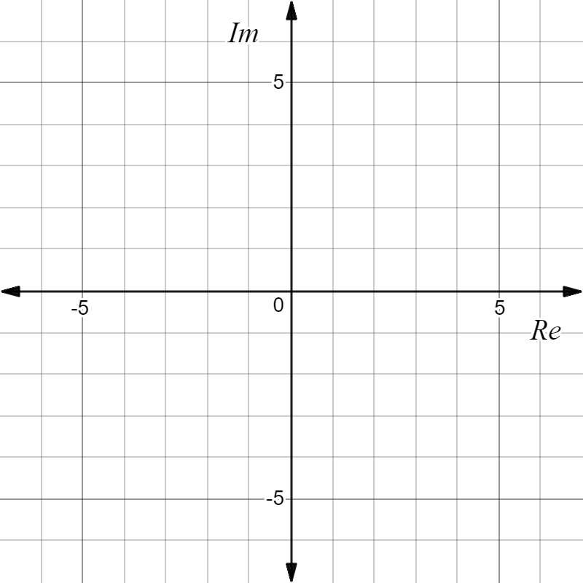

- On your diagram shade in the region which satisfies [2]

$\left|z+3-2i\right|≤3 ∩ \left|z\right|>\left|z+4-2i\right|$

- (7 marks)
Given $h\left(z\right)=z^{7}+iz^{4}-9iz^{3}+9$

- Show that $h\left(z\right)=(z^{4}-9i)(z^{3}+i)$ [1]

- Hence find all solutions to the equation $h\left(z\right)=0$ expressing your answers in the form $rcisθ$ where $r≥0$ and $-π<θ≤π$ . [6]

- (7 marks)
A subset of points $z$ in the complex plane form a circle with centre C and radius 4 units as shown.
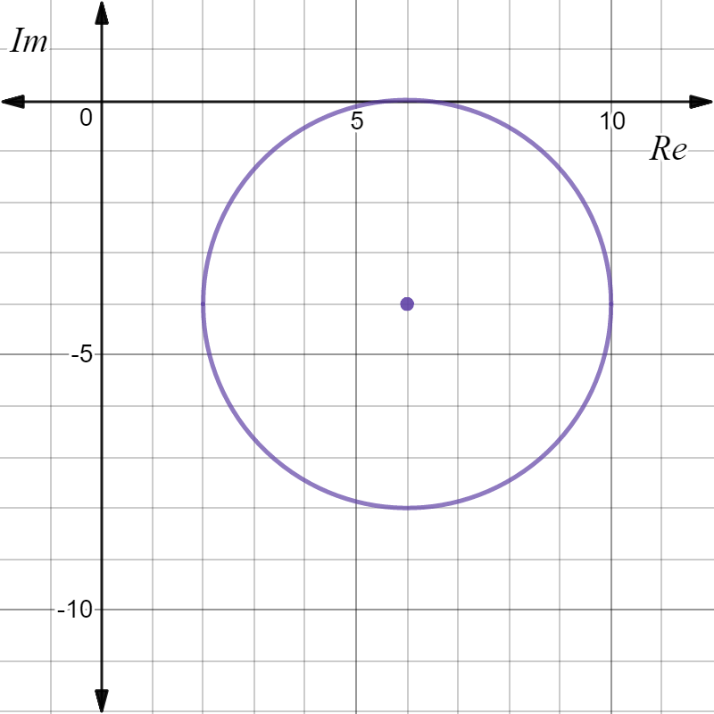

C

- Mark the position on the plane where $\left|z\right|$ is a minimum, clearly label this point A and give this minimum value exactly. [2]

- Mark the position on the plane where $\left|z+6i\right|$ is a maximum, clearly label this point B and give this maximum value exactly. [2]

- Determine, to three decimal places, the minimum value of $θ=arg\left(z\right), -π<θ≤π$. [3]

- (6 marks)
If $u=rcisθ , r>0 , -π<θ≤π$ and $w=1+\sqrt{3}i$ express each of the following in terms of $r$ and $θ$.

- $-u$ [2]

- $uw$ [2]

- $\frac{i\overline{u}}{w}$ [2]

- (7 marks)
Assume $x=cisθ$.

- Use De Moivre’s theorem to prove that $x^{k}-$ $\frac{1}{x^{k}}$ $=2isin(kθ)$ [3]

- Expand ${\left(x-\frac{1}{x} \right)}^{3}$ and use the outcome in part (a) above to prove that

$3sinθ-4\sin^{3}θ=sin3θ$. [4]

End of Test
This page has intentionally been left blank
You may use this space to extend or re-attempt an answer to a question or questions and should you do so then number the question(s) attempted and cross out any previous unwanted working.

